**Netaji Subhash Engineering College**

**Department of Computer Science & Engineering**

**B. Tech CSE 2nd Year 3rd Semester**

**2021-2022**

_______________________________________________________________________________________________

**Name of the Course: IT Workshop**

**Course Code: PCC-CS393**

**Name of the Student: Sanjoy Saha**

**Class Roll No.: 3**

**University Roll No.: 10900120003**

**Date of Experiment: 10/01/2022**

**Date of Submission: 10/01/2022**

**Program :-**

# 18. Write a program for the factorial of a number.

num = int(input("Enter a no. : "))

fact = 1

if num < 0:

    print("No factorial.")

elif num == 0:

    print("The Factorial of 0 is 1")

else:

    for i in range(1, num + 1):

        fact =fact * i

    print("The factorial of",num,"is",fact)

**Output :-**

* **Test case 1 -**

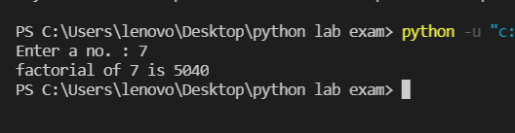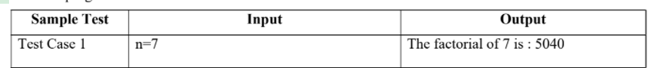

* **Test case 2 -**

**\*Test Case 3 –**

**------------------END-------------------**